DATA STRUCTURES & ALGORITHMS
Project Report
PHONE DIRECTORY APPLICATION USING DOUBLY-LINKED LIST
Submitted By: MALAIKA AROOJ (FA24B1-CS-093)
EMAN TARIQ (FA24B1-CS-039)
FATIHA TAHIR (FA24B1-CS-050)
ALISHBA ARSHAD (FA24B1-CS-053)
Submitted TO: SIR ADEEL KHALID
BCS III- A



Phone Directory Application Using Doubly Linked List:
1. Introduction:
A Phone Directory Application is a software system used to store, manage, and retrieve contact information such as name, phone number, and address.
This project demonstrates the practical implementation of Data Structures—especially the Doubly Linked List (DLL)—to perform real-world operations like:
- Adding contacts
- Searching contacts with suggestions
- Sorting contacts
- Deleting contacts
The application behaves similarly to a mobile contact book, where suggestions appear as the user types each character.

2. Objectives of the Project:
The main objectives of this project are:
- To understand the working of a Doubly Linked List
- To implement a real-world phone directory system
- To perform CRUD operations (Create, Read, Update, Delete)
- To provide search suggestions after each typed character
- To improve understanding of arrays, stacks, queues, and linked lists

3. Why Doubly Linked List?
A Doubly Linked List is chosen because:
- Each node contains:
  - Data
  - Pointer to previous node
  - Pointer to next node
- Traversal is possible in both directions
- Insertion and deletion are faster compared to arrays
- Sorting and searching become easier
Structure of a Node:
struct Contact {
string name;
string phone;
Contact* prev;
Contact* next;
};

4. System Features:
✅ Add Contact
- User enters name and phone number
- New contact is added at the end of the list
🔍 Search Contact with Suggestions
- Suggestions appear character by character
- Example:
  - Typing A → shows all names starting with A
  - Typing Al → shows names starting with Al
🗂 Sort Contacts
- Contacts are sorted alphabetically
- Uses Bubble Sort on Doubly Linked List
❌ Delete Contact
- User can delete a contact by name
- Memory is freed safely
📋 Display All Contacts
- Displays entire phone directory

5. Algorithms Used:
5.1 Add Contact Algorithm
- Create a new node
- If list is empty → make it head
- Else → link new node at the end
5.2 Search with Suggestions Algorithm
- Read character input
- Traverse list
- Compare prefixes
- Display matching names
5.3 Delete Contact Algorithm
- Search contact by name
- Adjust prev and next pointers
- Free memory
5.4 Sort Algorithm
- Traverse list
- Compare adjacent nodes
- Swap data if needed
- Repeat until sorted

6. Data Structures Used:
Data Structure | Purpose
Doubly Linked List | Store contacts
Arrays | Temporary storage
Stack | Undo operations (optional)
Queue | Recent searches (optional)

7. Implementation (Simplified Code Snippet):
void addContact(string name, string phone) {
Contact* newNode = new Contact();
newNode->name = name;
newNode->phone = phone;
newNode->next = NULL;
newNode->prev = NULL;

if(head == NULL) {
head = newNode;
} else {
Contact* temp = head;
while(temp->next != NULL)
temp = temp->next;
temp->next = newNode;
newNode->prev = temp;
}
}

8. Sample Output:
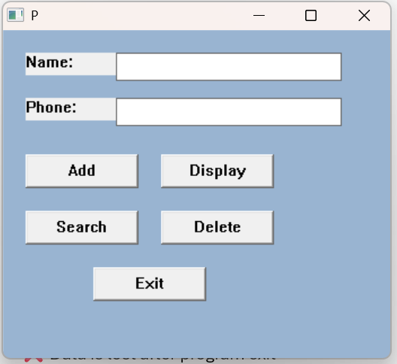
Add Contract:
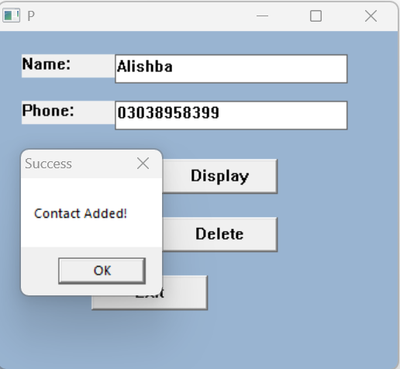

Display Contact:
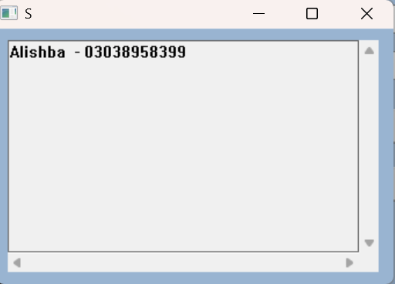
Delete Contact:
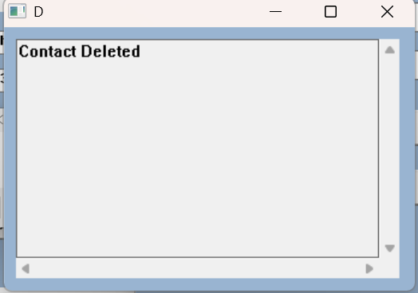

9. Advantages of the System:
✔ Fast insertion and deletion
✔ Memory efficient
✔ Real-time suggestions
✔ Easy to extend
✔ Real-world application

10. Limitations:
❌ No graphical interface
❌ Data is lost after program exit
❌ Case-sensitive search

11. Future Enhancements:
- File handling for permanent storage
- GUI using C++ graphics / Java / Python
- Search by phone number
- Auto-save feature
- Mobile app version

12. Conclusion:
The Phone Directory Application using Doubly Linked List successfully demonstrates how data structures are applied in real-life applications. The project improves understanding of linked lists, searching, sorting, and memory management, and is ideal for academic and practical learning purposes.

